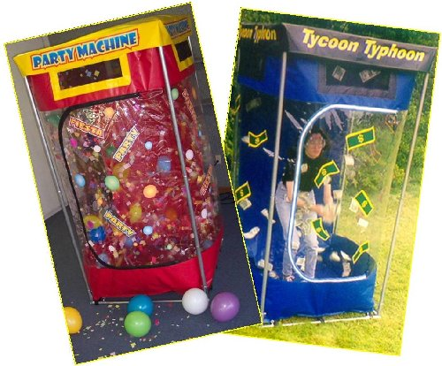
Money Machine

Preparation: Assemble Money Machine frame and attach Money Machine Chamber to frame

To Operate: Attach blower to Money Machine. Plug blower into a standard electric outlet. Check that chamber is closed. Turn blower on.
Rules & Regulations:
1. "Grab for Cash" rounds are: 30 seconds and allow contestants to grab as much money from the air as possible before time expires.
2. After entering the "Money Vault / Money Machine / Cash Cube", contestants must stand upright and cannot bend at the waist or knees to pick up cash from the floor.
3. Cash must be grabbed from the air and cannot be trapped on the sides of the "Money Vault / Money Machine / Cash Cube".
4. Contestants may, if necessary, use their feet to "kick up" cash that may accumulate in the bottom corners of the "Money Vault / Money Machine / Cash Cube" and cause the cash to blow up toward them.
5. Contestant will be directed to exit "Money Vault / Money Machine / Cash Cube" after time expires.
Contestant must be in good physical condition to participate. Persons with back, neck, knee or joint injury, respiratory problems or who may be pregnant should not participate. If you are currently under medical care, please consult your physician before participating on this event.

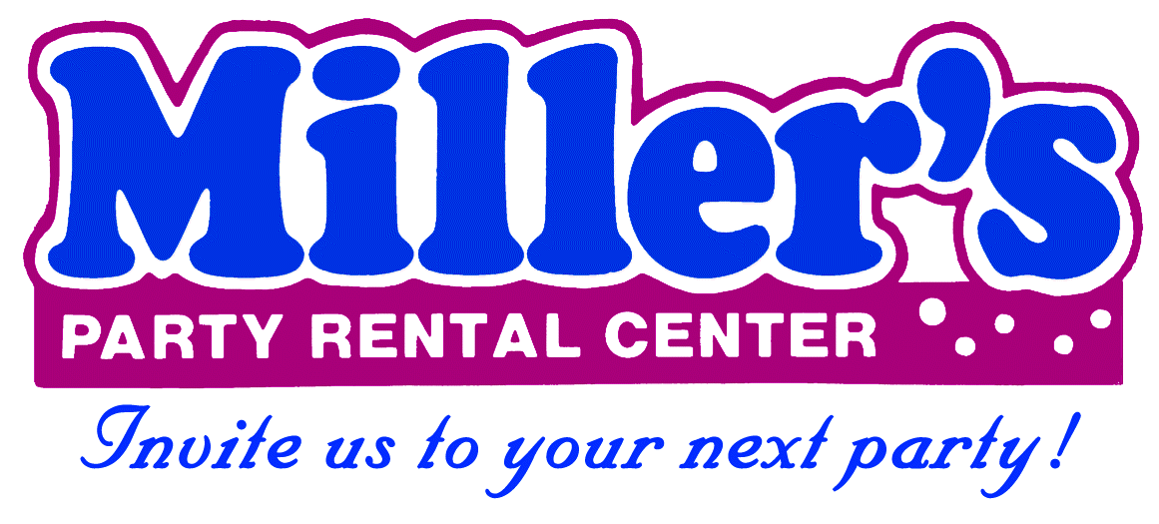
869 W. Waterloo Rd. Akron, OH 44314 330-753-9104
www.millersparty.com

