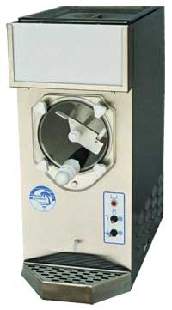
Margarita Machine

The Margarita Machine comes ready to use and fully operational.

Preparation:
Pour the mix into the hopper. As the hopper fills the drum will fill as well. The hopper and drum hold 3 ½ gallons. Once filled the machine is ready to operate.

To Operate:
Flip both switches to snow flake setting to begin freezing.

Once the mix is frozen, Serve!!!

To drain machine, flip both switches to the left to fully thaw mix. Then turn both switches to the neutral position and drain the remaining mix.

To Clean Up:
Once the machine has been drained fill the hopper with warm water and drain the water.


869 W. Waterloo Rd. Akron, OH 44314 330-753-9104
www.millersparty.com

