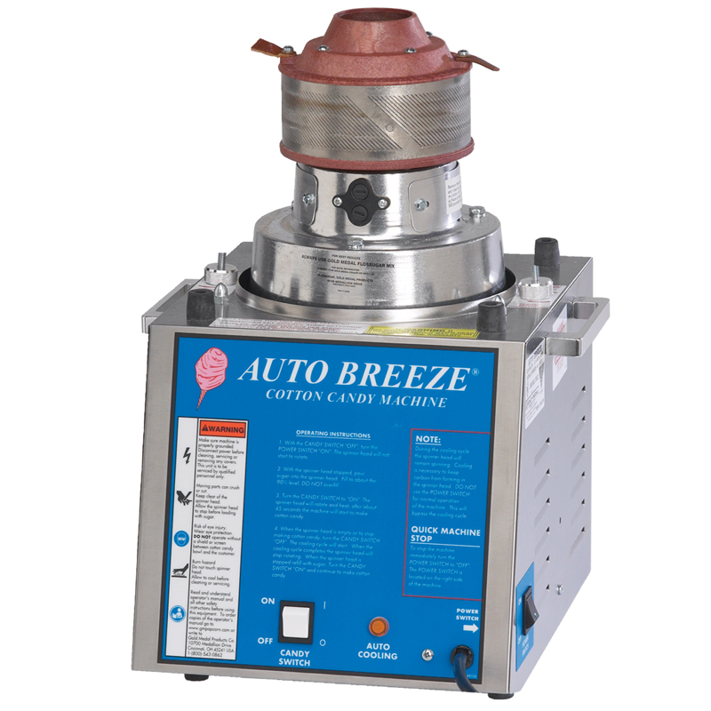
Cotton Candy Machine

Operational Tips
-Use only FLOSSUGAR in the Cotton Candy Machine
- Power Switch – Supplies power to the machine without turning on any components. Also acts as a “Master” on/off switch. Turning the power switch off will turn motor and heat off. (Power Switch is located on the side of the machine)
- Candy Switch – Turns motor and heat cycle on. Turning this switch “off” when finished making cotton candy allows the machine to start it’s cooling cycle. Note: Motor will continue turning during the cooling cycle, and will stop turning after 45-60
seconds. (Candy Switch is located on the front of the machine)

Operating Instruction
1. With the CANDY SWITCH “off”, turn the POWER SWITCH “on”. The spinner head will not start to rotate.

2. With the spinner head stopped, pour sugar into the spinner head. Fill to about the 90% level, DO NOT over-fill.

3. Turn the CANDY SWITCH to “on”. The spinner head will rotate and heat, after about 45 seconds the machine will start to make cotton candy.

4. When the spinner head is empty, or to stop making cotton candy, turn the CANDY SWITCH “off”. The cooling cycle will start. When the cooling cycle completes, the spinner head will stop rotating. When the spinner head is stopped; re-fill with sugar, turn the CANDY SWITCH “on”, and continue to make cotton candy.

To Make Cotton Candy Serving:


