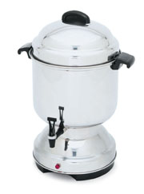
Coffee Makers

Operating Instructions
- Fill coffee pot with COLD water to desired amount.
- Add Coffee to basket (see equivalents below).
- Plug Coffee pot into standard electrical outlet.
- When Coffee has finished brewing, remove basket. The pot will keep the coffee Hot.

Cleaning Instructions
Rinse out coffee pot and basket before returning.
Never immerse coffee pot in water.

Brewing Time
It takes approximately ½ hour to brew coffee in 30 to 60 cup urns – 1 hour in 90 to 100 cup urns.

Coffee Equivalents

Number of Cups Coffee Measure
- 2 Cups
55 to 60 3 ½ Cups
90 6 Cups

One Pound of Coffee is equal to approximately 4- ¾ cups of ground coffee.

REMEMBER, you are renting this equipment. Be sure you are aware of the terms of your rental contract. Always return your coffee pot clean to avoid additional cleaning charges.


869 W. Waterloo Rd. Akron, OH 44314 330-753-9104
www.millersparty.com

