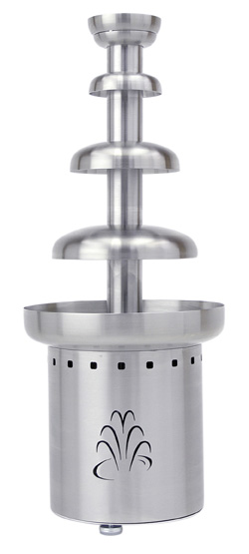

Chocolate Fountain Instructions

Preparation:
- Visually inspect all of the parts.
1 Fountain base, 1 Central core w/tiers, and 1 Auger.

- Assemble the fountain:
Before putting the central core on the base, turn the shaft manually. The shaft must turn. If the shaft will not turn, contact Miller’s Party Rental. Place the central core on the base. Then carefully insert the auger into place. Once the auger is in place, turn it 180 degrees to lock the auger into the central shaft. Level the fountain using the three adjustable feet on the bottom of the base.

- Test the fountain.
Plug in the unit. Turn the power switch to the right (warming light should be lit). The fountain should be in pre-heating position. Turn the same switch to the left to test the auger. Caution: The fountain is still heating at that position. To turn off the fountain, return the power switch to the middle position.
Make sure the fountain is level (chocolate will not flow evenly until the base is level).

- Pre-heat the fountain.
Turn the power switch to the right. Pre-heat @ 200 degrees for 30 minutes before adding chocolate wafers
Important: Fountain should be supervised at all times.

- Filling the fountain.
Fill the fountain with the chocolate chips. Once chips begin to soften begin stirring to smooth out the chocolate Set the power switch to the right to start the auger immediately after the chocolate has melted in the base of the fountain. The fountain should be flowing freely in approximately 30 minutes. If chocolate is not flowing freely adjust the thermostat higher and continue to heat. Once chocolate is flowing smoothly you may adjust the thermostat to a lower temperature so that the chocolate doesn’t become too thin.

To Clean:
- Turn off and unplug the fountain.
- Remove the central core and auger – wash with hot water and mild dish soap.
- Empty the base and scrape the leftover chocolate out. Using a sponge or damp cloth wash out the inside of the bowl with hot water and mild dish soap. Rinse carefully.
Caution: Do not spray water on the motor or the electrical parts of the base.

Most frequently asked question:
- Why is the chocolate flowing to only one side of the fountain?
- It is very important that the fountain be leveled BEFORE you pour the chocolate in. Level the fountain using the feet. They screw up and down. Chocolate may be to thin due to overheating. Turn thermostat down to 100 degrees.
If you need assistance, call our 24-hour emergency service at (330) 753-9104.



